Sales Dashboard| Requirements

**Dashboard Purposes**

* The purpose of the sales dashboard is to present the overview of sale metrics and trends to analyze year-over-year sales performances and understand the sales trends.

**Key Requirements**

**KPI Overview**

* Display a summary of total sales, profits, quantities of the current and previous year.

In Tableau, to show the summary of total sales for current year and last year.

Created the CY Sales and LY Sales, % of Difference between CY and LY.

In Calculated Field, **Sales**, **Profits**, **Quantities**

* **CY Sales = IF YEAR([Order Date])=[Select Year] THEN [Sales] END**
* **LY Sales = IF YEAR([Order Date])=[Select Year]-1 THEN [Sales] END**
* **% of difference sales = (SUM([CY Sales])-SUM([LY Sales]))/sum([LY Sales])**

**Sale Trend**

* Present the data for each KPI a monthly basis for both the current and present year.
* Identify the **highest and lowest sale trends**, make them easy to recognize. (Same with Profits and Quantities)

Min & Max Sales =

IF SUM([CY Sales])=WINDOW_MAX(SUM([CY Sales]))

THEN SUM([CY Sales])

ELSEIF SUM([CY Sales])=WINDOW_MIN(SUM([CY Sales]))

THEN SUM([CY Sales])

END

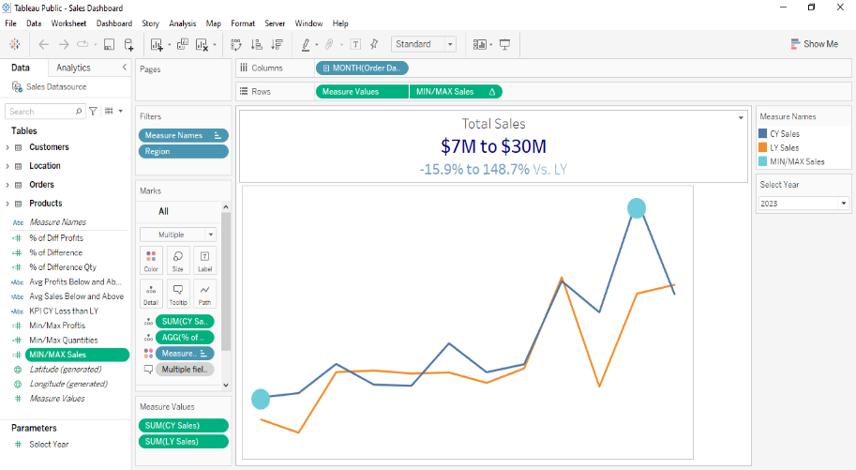

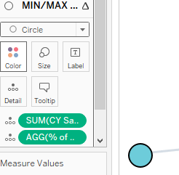

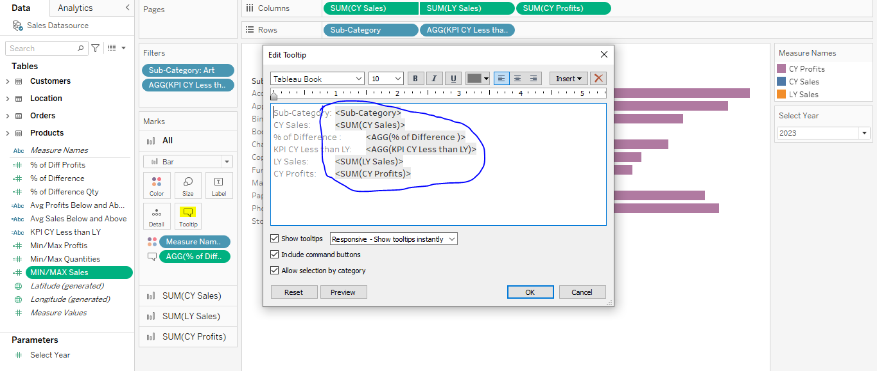**In Tooltips,**

**We can able to adjust based on requirements.**

**Product Subcategory Comparison**

* Compare sale performance by different product sub categories for the current and previous year.

For the CY Sales and LY Sales, combine using **dual axis** in charts.

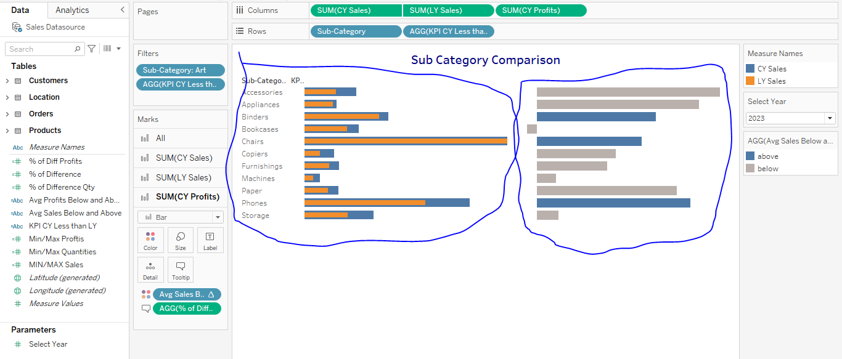

* Include the comparison of Sales and Profits.

**Weekly Trends for Sales and Profits**

* Present weekly sales and profit data for the current year
* Display the average weekly values.
* Highlight weeks that are above and below the average to draw attention to sales and profit performance.

**Avg Sales of Below and Above** = IF SUM([CY Sales]) > WINDOW_AVG(SUM([CY Sales]))

THEN 'above'

ELSE 'below'

END

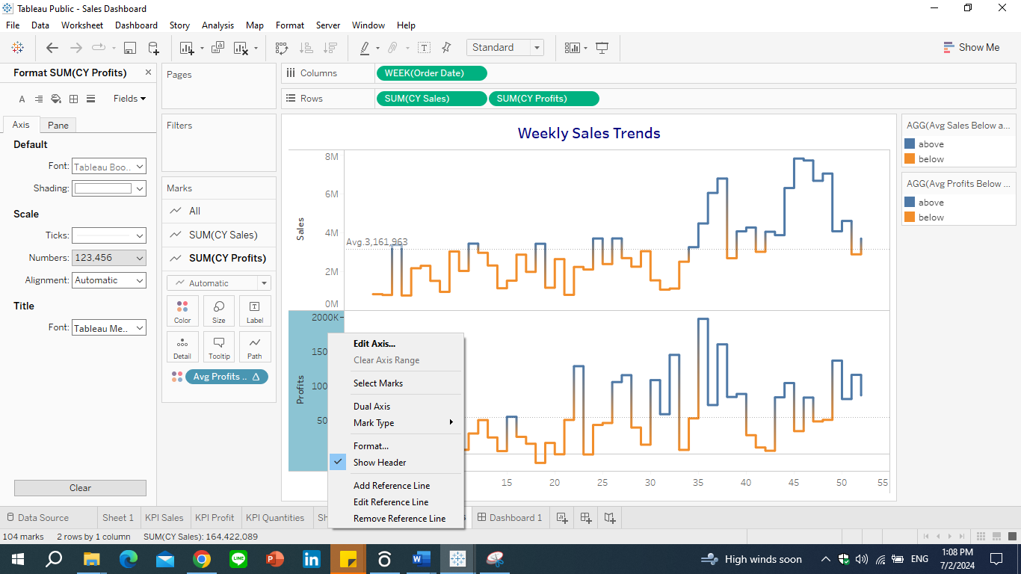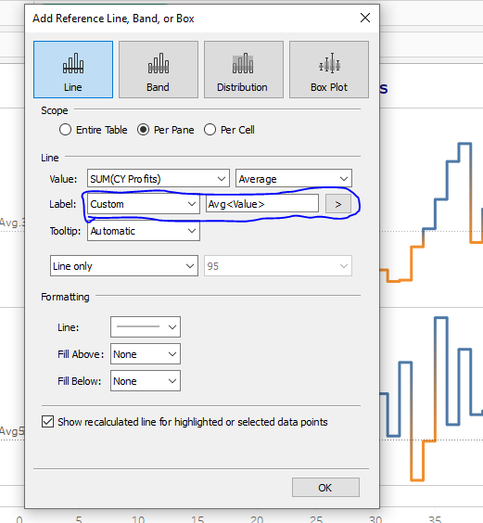

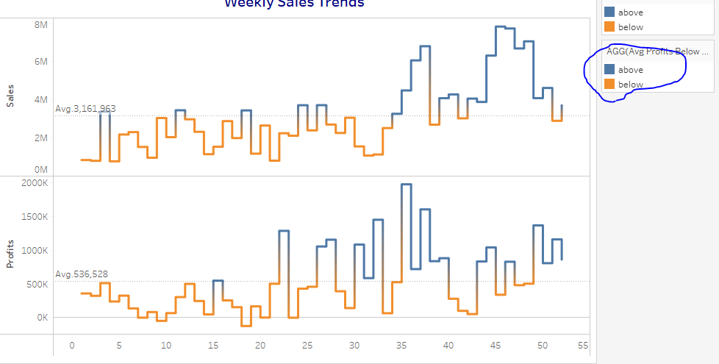

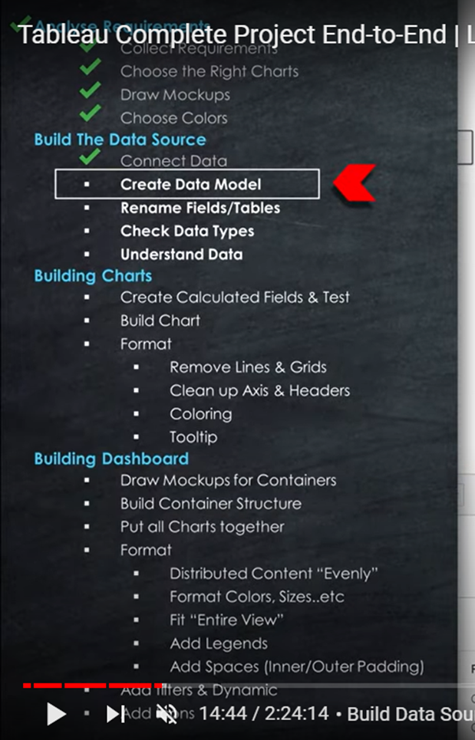

**Customer Dashboard/Requirements**

* Customer Dashboard aims to provide an over of customer data, trends and behaviors. It will help marketing team and management to understand customer segments and improve customer satisfaction.

**Key Requirements**

**KPI Overview**

* Display a summary of total number of customers,total sales per customers, total number of orders for the current and previous year.

**Customer Trends**

* Present the data for each KPI for current and previous year.
* Identify months with highest and lowest sales and make them easy to recognize.

**Customer Distribution by number of orders**

* Represent the distribution of customers based on the number of orders they have placed to provide into customer behavior, loyalty, engagement.

**Top 10 Customers by Profits**

* Present top 10 customers who have generated the highest top 10 profits for the company.
* Show additional information like Rank, number of orders, current sales, current profits and the last order sales.